**Trucker Manual**

**Installation**

1. Double-click the **TruckerSetup installer icon** shown below:



1. The installation wizard will appear as shown below. Click **Next**.

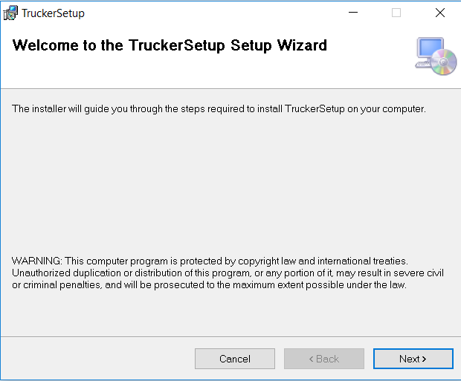

1. In the next dialog box, choose the location where you want to install the Trucker application by clicking the **Browse** button. If you already prefer the default location provided, just click **Next.**

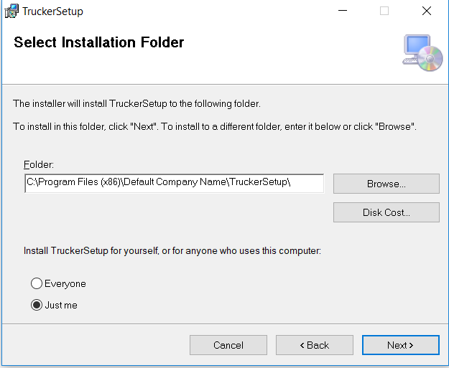

1. In the next dialog box, click the **Next button** to confirm the installation.
2. After the installation process is finished, the Trucker App is now installed.

**Trucker Application Usage**

1. A shortcut icon for the Trucker has been created in the Desktop after installation. Double-click the icon to open the application.

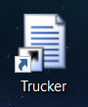

1. Upon opening the application, a form will appear containing seven tabs as shown below:

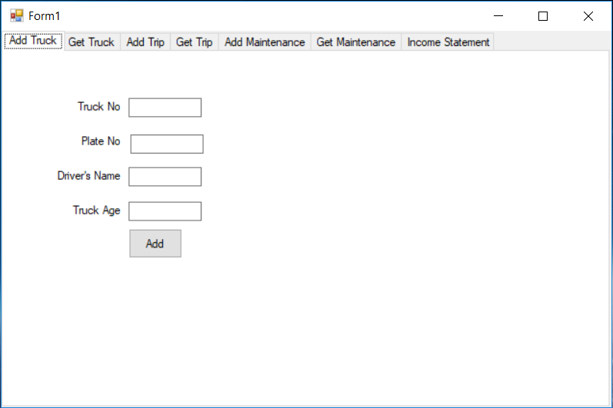

1. Adding a Truck
   1. To add a truck, click the **“Add Truck”** tab.
   2. Populate the truck fields and click the **“Add”** button
   3. A dialog box will appear that the new truck has been stored.

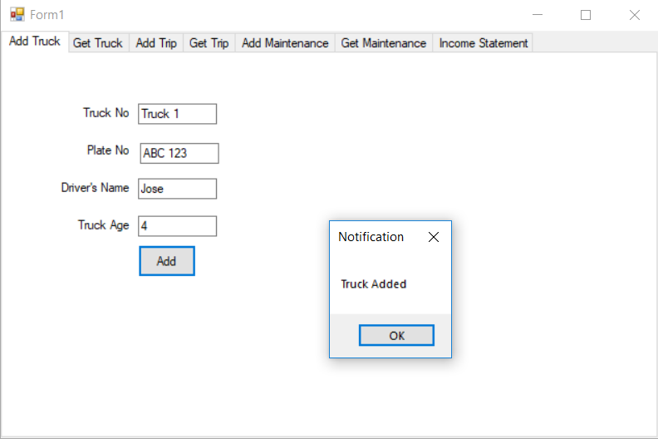

1. Viewing Trucks
   1. To view stored truck details, click the **“Get Truck”** tab. A table will be shown containing the stored truck details.
   2. To see all of trucks, select **“All”** from the dropdown box of the Filterssections and then click the **Filter** button

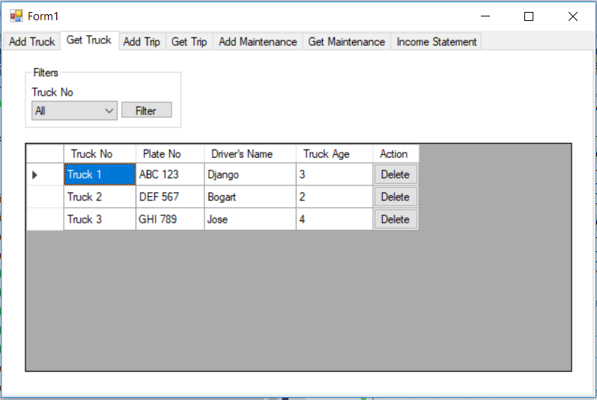

* 1. To filter trucks in the table, select the desired truck from the dropdown box and then click the **Filter** button

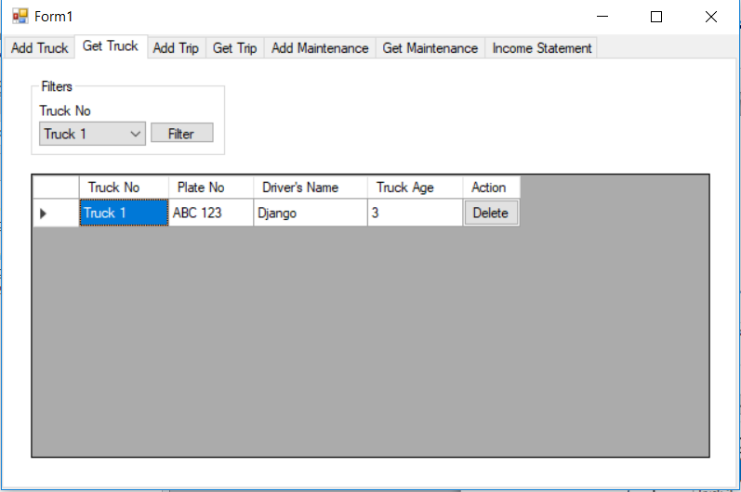

* 1. To delete a truck, click the **“Delete”** button of the truck row in the table. This will remove the truck from the storage and the table.

1. Adding a Trip
   1. To add a trip, click the “Add Trip” tab.
   2. Populate the trip fields and click the **“Add”** button
   3. A dialog box will appear that the new trip has been stored.

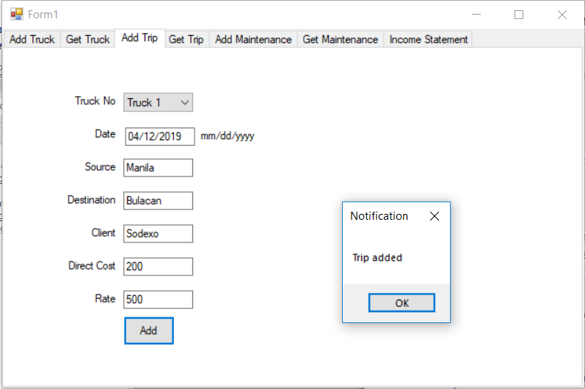

1. Viewing Trips
   1. To view stored trips, click the **“Get Trip”** tab. A table will be shown containing the stored trips.
   2. To see all of trips, select **“All”** from the dropdown box of the Filterssections and then click the **Filter** button

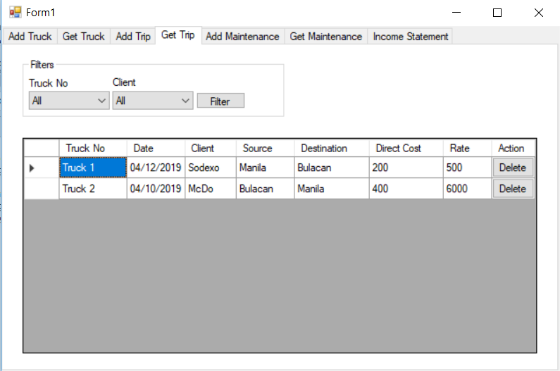

* 1. To filter trips in the table, select the desired truck number and/or client from the dropdown boxes and then click the Filter button
  2. To delete a trip, click the **“Delete”** button of the trip row in the table. This will remove the trip from the storage and the table.

1. Adding Maintenance Cost
   1. To add a maintenance cost, click the **“Add Maintenance”** tab.
   2. Populate the maintenance fields and click the **“Add”** button
   3. A dialog box will appear that the new trip has been stored.

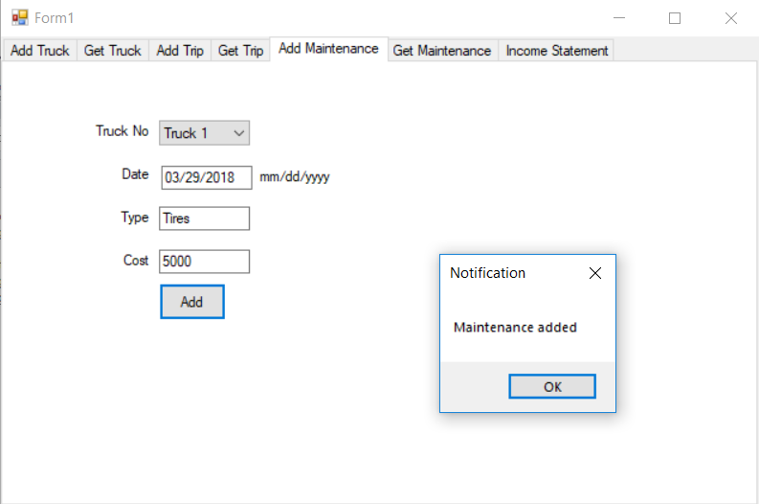

1. Viewing Maintenance Costs
   1. To view stored maintenance costs, click the **“Get Maintenance”** tab. A table will be shown containing the stored maintenance costs.
   2. To see all of maintenance costs, select **“All”** from the dropdown box of the Filterssections and then click the **Filter** button.

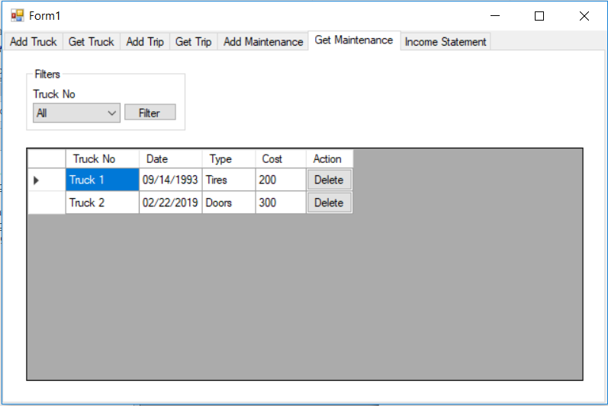

1. To filter maintenance costs in the table, select the desired truck number from the dropdown box and then click the **Filter** button
2. To delete a trip, click the **“Delete”** button of the maintenance cost row in the table. This will remove the maintenance from the storage and the table.
3. Viewing Income Statement
   1. To view the income statement, click the **“Income Statement”** tab.

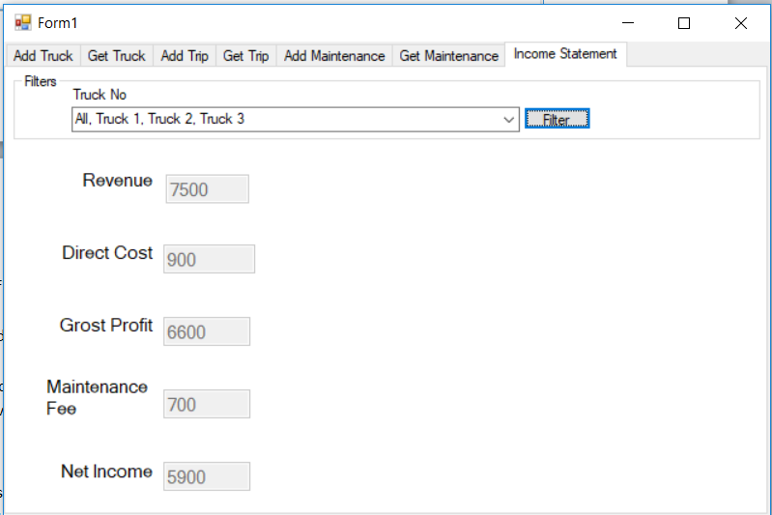

* 1. To see the income statement from all trucks, check **“All”** from the check boxes in the **Truck No dropdown box**. This will check all of the other check boxes. Afterwards, click the **Filter** button.

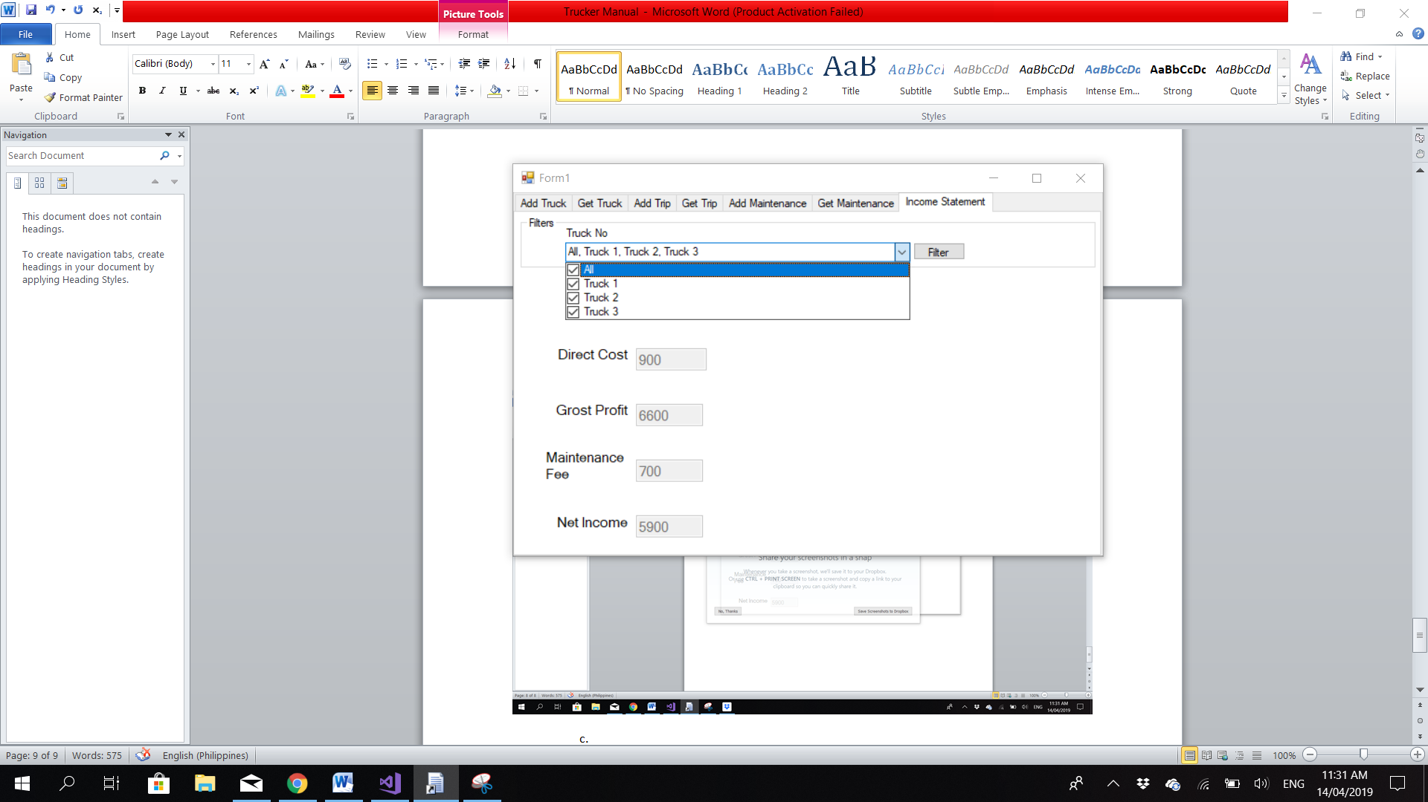

* 1. To see the income statement of specific trucks, tick the check boxes of the desired trucks in the **Truck No dropdown box**. Afterwards, click the **Filter** button.